STUDY ON PROCESSORS

MIPS:

MIPS (Microprocessor without Interlocked Pipelined Stages) is a family of reduced instruction set computer (RISC) instruction set architectures, developed by MIPS Computer Systems, now MIPS Technologies.

The key concepts of the MIPS architecture are:

* Five-stage execution pipeline: fetch, decode, execute, memory-access, write-result.
* Regular instruction set, all instructions are 32-bit.
* Three-operand arithmetical and logical instructions.
* 32 general-purpose registers of 32-bits each.
* No status register or instruction side-effects.
* No complex instructions (like stack management, string operations, etc.)
* Only the load and store instruction access memory.
* Memory-management unit maps virtual to actual physical addresses.

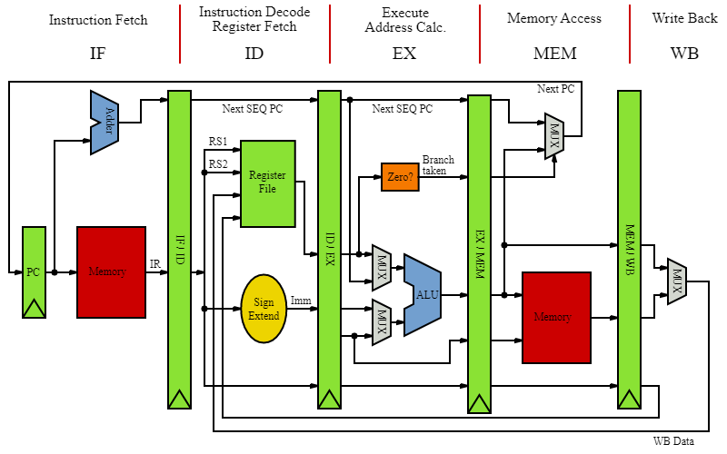

ARM:

ARM (formerly an acronym for Advanced RISC Machines and originally Acorn RISC Machine) is a family of reduced instruction set computer instruction set architectures for computer processors, configured for various environments.

The key concepts of the ARM architecture are:

* Load/store-based architecture.
* Single-cycle instruction execution.
* Consistent 16x32 bit register file.
* Link register.
* Easy decoding and pipelining.
* Power-indexed addressing modes.
* Fixed 32-bit instruction set.
* An orthogonal instruction set.
* Hardware virtualization support.

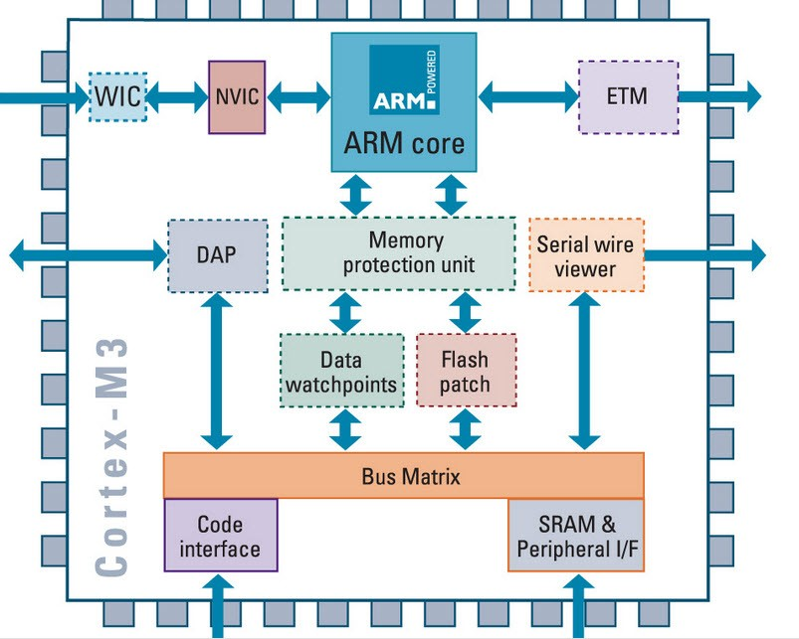

x86:

x86 is a family of complex instruction set computer (CISC) instruction set architectures initially developed by Intel based on the Intel 8086 microprocessor and its 8088 variant.

The key concepts of the x86 architecture are:

* The X86 instruction set allows for dynamic lengths for instructions.
* These registers on 32-bit x86 are in fact 32 bits or 4 bytes in size.
* The X86 CPU architecture uses little-endian ordering for memory storage.
* It contained write protect feature and offered a built in math co-processor that offloaded complex math operations from the main CPU.
* It has an addressable physical memory of 4 GB and data transfer width of 32-bits.

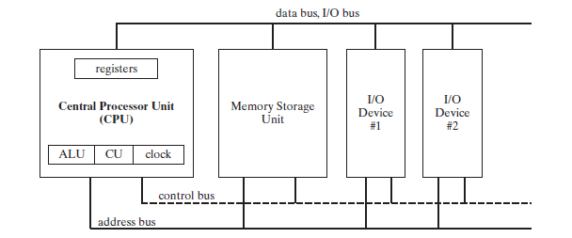

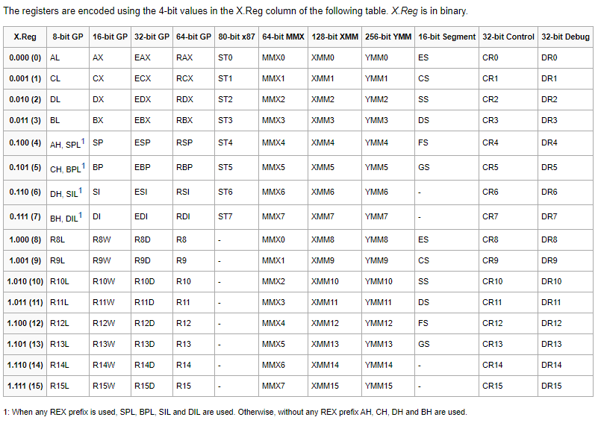x86_64:

x86-64 (also known as x64, x86_64, AMD64, and Intel 64) is a 64-bit version of the x86 instruction set, first released in 1999. It introduced two new modes of operation, 64-bit mode and compatibility mode, along with a new 4-level paging mode.

The key concepts of the x86 architecture are:

* 64-bit integer capability
* Additional registers & Additional XMM (SSE) registers
* Larger virtual address space
* Larger physical address space
* Larger physical address space in legacy mode
* Instruction pointer relative data access
* SSE instructions
* No-Execute bit
* Removal of older features

